
PROJECT
DESIGNATION
ABOUT
Utensils _Shop

Has successfully designed in Utensils _Shop
Page
During E-Project of (1st Semester)
Aptech worldwide Computer Education
CERTIFICATE OF COMPLETION
MUHAMMAD FAHAD
HANIA MOHIUDDIN
HASSAN SALMAN
ZOHAIB YAR REHMAN

This is Certify that
ACKNOWLEDGEMENT

I would like to acknowledge all those who have given me moral support and helped in making the project a success.

I wish to express my gratitude to “E-Project” Team at Aptech Orangi Town Karachi Campus who guided and helped me. Also, I would like to express my gratitude to all the faculty members of my Centre for not only providing me opportunity to work with them on this project, but also for their support and encouragement throughout the process.

I also express my sincere gratitude to E-Project Team from Aptech Orangi Town Karachi Campus and my project guide at the organization for his valuable guidance and support for completion of this project.

Final, I would like to offer many thanks to all my colleagues for their valuable suggestions and constructive feedback.

Problem Statement
- To develop a responsive website for showcasing kitchen utensils online.
- To provide a digital platform for customers to explore cookware, cutlery, and dinner sets.
- To display products using a modern and user-friendly card layout.
- To allow users to view detailed product information through modal popups.
- To implement smooth navigation using anchor-based scrolling.
- To create a comparison section for evaluating different utensils.
- To design an attractive hero section with promotional content.
- To integrate a contact form for customer inquiries.
- To implement scroll animations and dynamic visual effects.
- To ensure the website is fully responsive using Bootstrap framework.

requirement specification:
- HTML5 for structure of the website.
- CSS3 for styling and background design.
- Bootstrap5 for responsive layout.
- JavaScript and jQuery for animations and smooth scrolling.
- Modal functionality for product details display.
- Contact form for user interaction.

Gui Design
INDEX: Main landing page with navigation bar and hero section.
Product model: Card based product display with modal popups.
Compare model: Side by side utensil compare section.
Contact model: Customer inquiry from interface.
Animation model: Smooth scrolling and scroll reveal effects.

Task sheet

NAME | Contribution in project
MUHAMMAD FAHAD | 40%
HANIA MOHIUDDIN | 20%
HASSAN SALMAN | 20%
ZOHAIB YAR REHMAN | 20%

Task sheet
S.NO | Task | EPROJECT | DONE BY | STATUS
1 | Navigation Bar Implementation | Utensils _shop | Hassan Salman | Completed
2 | Hero Section design | Utensils _shop | Hania Mohiuddin | Completed
3 | Product cards & model integration | Utensils _shop | Muhammad Fahad | Completed
4 | Compare section development | Utensils _shop | Muhammad Fahad | Completed
5 | Contact Form Implementation | Utensils _shop | Zohaib yar Rehman | Completed

SOURCE CODE WITH COMMENTS
HTML, CSS, and JavaScript source code is included separately with proper comments.

USER GUIDE
1. Open the website in a browser.
2. Use navigation bar to move between sections.
3. Click 'View Details' to see product information.
4. Use Compare section to compare utensils.
5. Fill Contact form to send message.

DEVELOPER GUIDE
Project Structure:
- index.html – Main structure file
- style.css – Styling and UI design
- script.js – Animations and interactions
- images folder – Product images

DATABASE DESIGN / STRUCTURE
This project is a static website and does not use a database. However, if implemented dynamically, the database would include tables such as:
- Products (ProductID, Name, Description, Price, Image)
- Customers (CustomerID, Name, Email, Message)

DATA FLOW DIAGRAM (DFD)
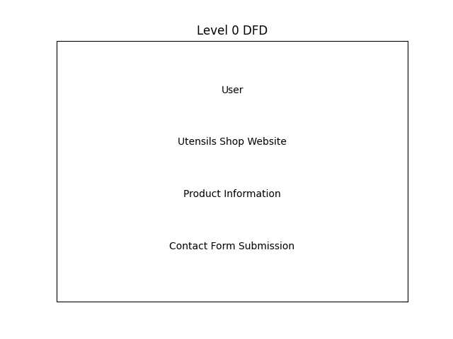

FLOWCHART
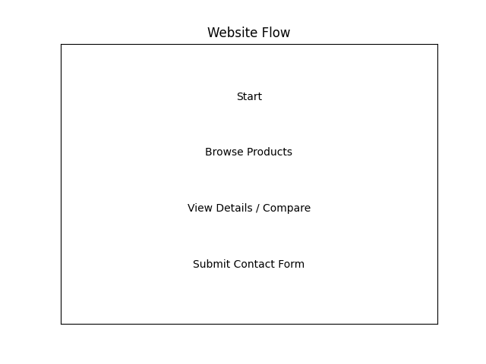

PROCESS DIAGRAM

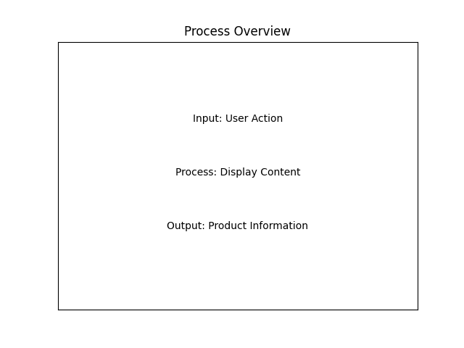

E-PROJECT SYNOPSIS
Utensils Shop is a responsive web-based project developed using HTML, CSS, Bootstrap, JavaScript, and jQuery. The website displays premium kitchen utensils including cookware, cutlery, and dinner sets. The system allows users to explore products, view detailed information through modal popups, compare utensils, and contact the company online.

E-PROJECT ANALYSIS
- Requirement of online presence for utensil business.
- Need for responsive and user-friendly interface.
- Product showcase with detailed view functionality.
- Comparison section for better decision making.
- Contact form for customer inquiries.

E-PROJECT DESIGN
Frontend Technologies Used:
- HTML5 – Structure of website
- CSS3 – Styling and gradient background
- Bootstrap 5 – Responsive layout
- JavaScript & jQuery – Smooth scrolling and animations

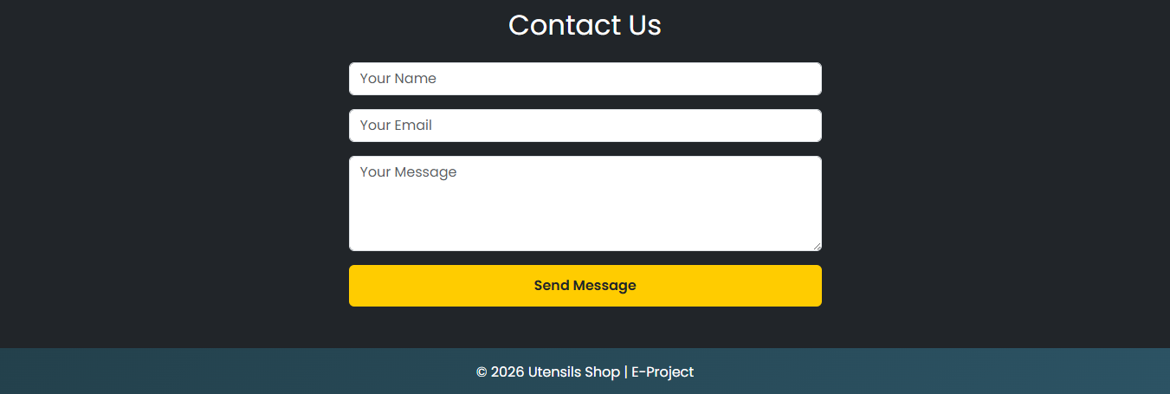
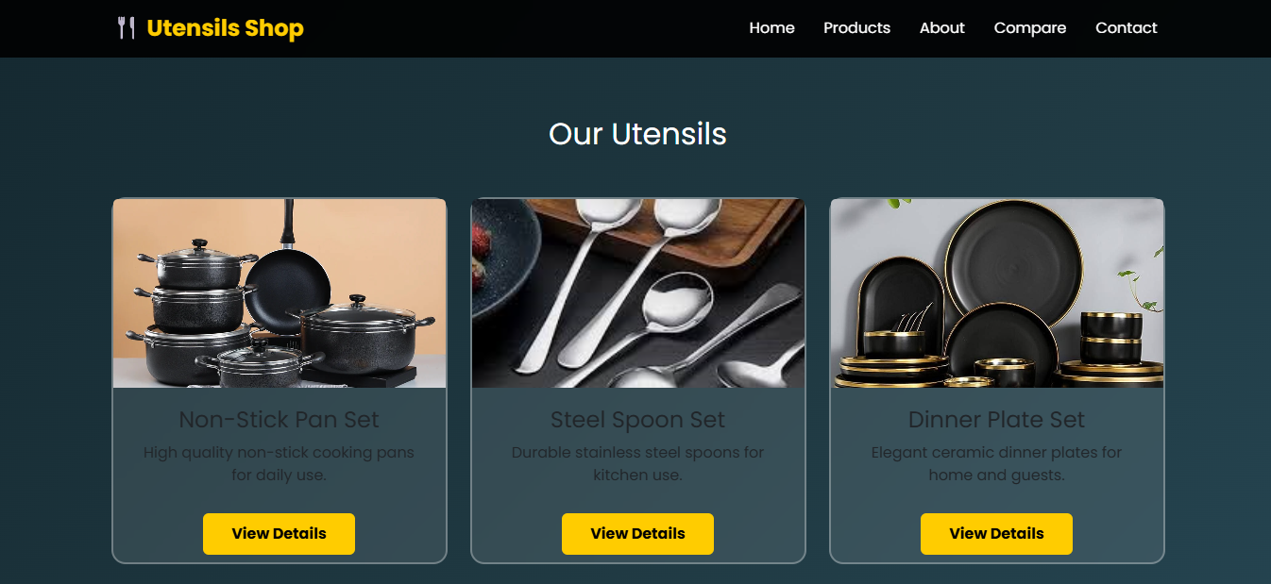
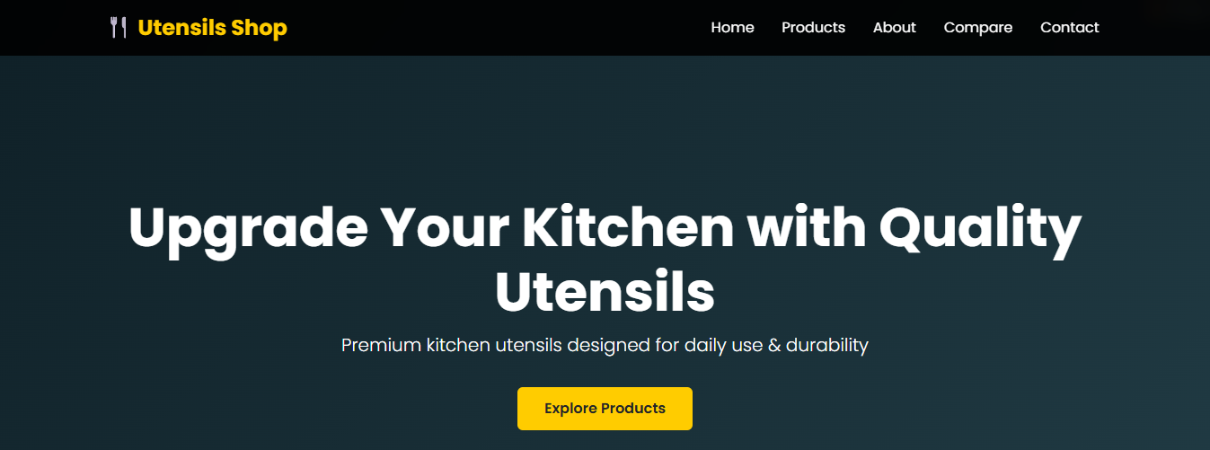
SCREENSHOTS

